8 QUEEN PROBLEM

AIM:
To write a Python program that solves the 8 Queens Problem using the Backtracking algorithm by placing eight queens on an 8×8 chessboard such that no two queens attack each other.

OBJECTIVES:
- To place 8 queens on an 8×8 chessboard without any two queens attacking each other.
- To use the Backtracking algorithm to find a valid solution.
- To check for conflicts in rows, columns, and diagonals before placing each queen.
- To display the final arrangement of queens on the chessboard.

ALGORITHM:
Algorithm: 8 Queens Problem Using Backtracking
- Start the program.
- Initialize an 8×8 chessboard (or an array to store queen positions).
- Place the first queen in the first row.
- For each row:
  - Try placing the queen in each column.
  - Check whether the position is safe:
    - No queen is present in the same column.
    - No queen is present in the left diagonal.
    - No queen is present in the right diagonal.
- If the position is safe:
  - Place the queen.
  - Move to the next row.
- If no safe position is found:
  - Remove the previously placed queen (backtracking).
  - Try the next possible position.
- Repeat the process until all 8 queens are placed successfully.
- Display the chessboard with the queen positions.
- Stop the program

FLOWCHART:

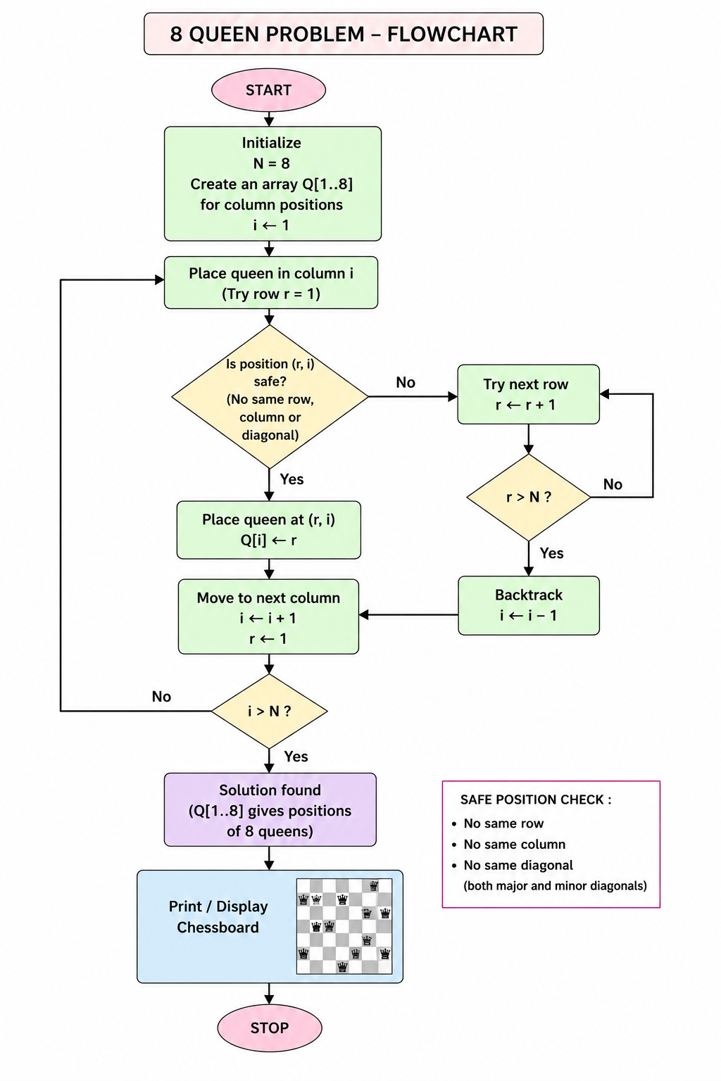
SOURCE CODE :
# 8 Queens Problem using Backtracking (Python 2)

N = 8
board = [-1] * N

def check(row, col):
for i in range(row):
if board[i] == col or abs(board[i] - col) == abs(i - row):
return False
return True

def print_board():
for i in range(N):
for j in range(N):
if board[i] == j:
print "Q",
else:
print ".",
print

def queen(row):
if row == N:
print_board()
return True

for col in range(N):
if check(row, col):
board[row] = col

if queen(row + 1):
return True

board[row] = -1

return False

queen(0)
OUTPUT :

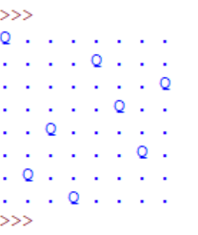

RESULT:
The 8 Queens Problem was successfully implemented using the Backtracking algorithm in Python. The program places 8 queens on an 8×8 chessboard such that no two queens attack each other and displays the valid chessboard arrangement.

A : Clean
B : Clean

Aim
To write a Python program to solve the Water Jug Problem using Artificial Intelligence.

Objective
- To obtain the required amount of water using two jugs.
- To apply the concept of State Space Search.
- To find the solution step by step.

Algorithm
- Start the program.
- Take two jugs of capacities 4 L and 3 L.
- Fill the 4 L jug.
- Pour water from the 4 L jug into the 3 L jug until it is full.
- Empty the 3 L jug.
- Pour the remaining water from the 4 L jug into the 3 L jug.
- Fill the 4 L jug again.
- Pour water into the 3 L jug until it becomes full.
- Now, the 4 L jug contains exactly 2 L of water.
- Stop.

SOURCE CODE

# Water Jug Problem

jug4 = 0
jug3 = 0

print("Initial State:", (jug4, jug3))

jug4 = 4
print("Fill 4L Jug:", (jug4, jug3))

jug4, jug3 = 1, 3
print("Pour 4L -> 3L:", (jug4, jug3))

jug3 = 0
print("Empty 3L Jug:", (jug4, jug3))

jug4, jug3 = 0, 1
print("Pour Remaining Water:", (jug4, jug3))

jug4 = 4
print("Fill 4L Jug Again:", (jug4, jug3))

jug4, jug3 = 2, 3
print("Pour 4L -> 3L:", (jug4, jug3))

print("\nGoal Achieved: 2 Litres in 4L Jug")

OUTPUT

Initial State: (0, 0)
Fill 4L Jug: (4, 0)
Pour 4L -> 3L: (1, 3)
Empty 3L Jug: (1, 0)
Pour Remaining Water: (0, 1)
Fill 4L Jug Again: (4, 1)
Pour 4L -> 3L: (2, 3)
Goal Achieved: 2 Litres in 4L Jug

